# Curriculum Vitae

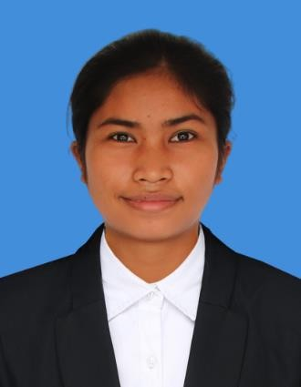#21F, Street 371 Phum Tropeang Chhuk (Borey Sorla), Sangkat Tek Thla, Khan Sen Sok, Phnom Penh, Cambodia Tell: 0976757230 / 089486361

Email: [sreyka.thor@student.passerellesnumeriques.org](mailto:sreyka.thor@student.passerellesnumeriques.org)

**Objective:** Appling for a position of PHP Developer

# PERSONAL DATA

Full name : Sreyka Thor Sex : Female Nationality : Khmer

Place of birth : Siem Reap

Date of birth : 10th February 2004

Marital status : Single

# EDUCATION BACKGROUND

2021 to present : Pursuing Associate Degree in Web Programing, Passerelles numeriques Cambodia (PNC)

Term 01: General English 01, Professional Life 01, Logic

Term 02:?

Term 03:?

Term 04:?

2018 to 2021 : High School Certificate from Siem Reap (Pouk high school)

# WORK EXPERIENCE

Passerelles Numeriques Cambodia (PNC)

Project 1(05/08/22) : We worked on Figma to design flyer of the Web Essential Company and I have successful.

Project 2(08/22) : For second project, I work in the pair work to design the website to find job.

We used HTML, CSS, SASS and Figma and I can do it successfully.

Project 3(24/10/22-28/10/22) : For this project, I work with pair work for make a game relate to a health. We use python language. (Algorithm)

Project 4(28/11/22-02/12/22) : For this project, I create E-commerce Website to sell products. I used HTML, CSS, Java Script.

Project 5(16/01/23-15/02/23) : In this project, I work in team to make a website to booking a cinema ticket. We use PHP and Database to make it.

Project 6(24/04/23-01/05/23) : In this project, I work in pair. We used concept of (OOP) with type script to create an airline management system.

Additional Experience: - 06-07, September, 2022 join Ideathon

* 17, June, 2022 visited company (Z1 Flexible Solution)
* 08 July 2022 visited (Online Company)
* 17, Feb,2023 visited (Atech Group Co.,Ltd)

# SKILLS

Technical Skill: Microsoft, HTML, CSS, Python, SASS, Java Script, PHP, and Database

Soft Skills : Communication, Teamwork, Problem Solving, Responsibility

# LANGUAGES

Khmer : Mother tongue

English : Intermediate (Writing, Reading, Listening, Speaking)

# INTEREST

* Researching New Programming Language
* Playing sports
* Travelling
* Listening to music

# REFERENCES

**Mr**. Sim Hul

**Position**: Students' Life and Alumni Engagement Coordinator  
**Tel**: 012/098 656 096

**Email**: sim.hul@passerellernumeriques.org

**Ms**. Lavy Hou

**Position**: Professional Trainer at PNC  
**Tel**: 012 723 877

**Email**: lavy.hou@passerellernumeriques.org

**Mr**. Narin Noeurn

**Position**: English Trainer at PNC  
**Tel**: 012 233 885/ 086 979 933

**Email**: narin.noeurn@passerellernumeriques.org

**Mr**. Rady Y

**Position**: WEP Coordinator at PNC  
**Tel**: 012 251 803

**Email**: rady.y@passerellernumeriques.org